Technical design document

Project: AXM Vehicle Manufacturer
Document history
Version | Author | Comment
26.05.2022 | Stefan Ristovski | Version 1.0

Contents
Project description 3
Extended Data Types 3
Table and Forms 4
Queries 16
Classes 16
D365 extensions 18
Reporting 19
Menu items 19
Menu 20
Security 20

Project description
In this project we will explore the process of manufacturing one vehicle. To achieve the required process, we will implement solution through Dynamics 365 Finance & Operations. The module that we will create will be called AXM Vehicle Manufacturer.
While working on this project we will get familiar with the capabilities of the Dynamics 365 Finance & Operations as how to create a different type of Forms, Tables, EDTs, Enums, Reports, Menus, Menu Items and Security as well. But the main thing we will experiment with is extensions. This is unique feature compared to the previous versions of AX.

Base Enums
Name | Label | Values
AXMVehiclePart | Vehicle part | Door, Engine, Wheels, Chassis
AXMVehicleType | Vehicle type | Sedan, Coupe, SUV, Hatchback, Truck
AXMStatus | Status | Open, Validated, Completed

Extended Data Types
Name | Extends | Type | Label
AXMVehiclePartId |  | String | Vehicle part identification
AXMPartQty | InventQty | Real | Part quantity
AXMVehicleManufacurer | VendAccount | String | Vehicle manufacturer
AXMVehicleColor | EcoResColorName | String | Vehicle color
AXMCOEmissionValue |  | Real | CO emission threshold
AXMVehicleId |  | String | Vehicle identification

Table

Vehicle manufacturer parameters - AXMVehicleManufacturerParameters
Parameters tables are used for configuring setups for a particular module. It always contains only one record, since only one setup can be active per module. In this table we will specify the minimum CO emission value for a car to be build.

Properties
Properties
Name | AXMVehicleManufacturerParameters
FormRef | AXMVehicleManufacturerParameters
Label | Vehicle manufacturer parameters
Table Group | Parameters
Modified Date Time | Yes
Modified By | Yes
Created Date Time | Yes
Created By | Yes

Fields
Name | Field type | EDT | Properties
COEmissionValue | Real | AXMCOEmissionValue | AllowNegative: No
ManufacturingDateLimit | Date | TransDate | HelpText: Vehicle date shouldn’t be older than the date specified in the parameters form.
Key | Integer | ParametersKey | AllowEdit: No, AllowEditOnCreate: No  Visible: No  Mandatory: Yes

Indexes
Name | Field list | Properties
KeyIdx | Key | AllowDuplicates: No  AlternateKey: Yes

Methods to be implemented: find().

The find method for parameter table is slightly different than find methods on regular tables. Please check AssetParameter table as example of what should be in the method.

Form
Name | Form Template | Label
AXMVehicleManufacturerParameters | TableOfContents | Vehicle manufacturer parameters

DataSource: AXMVehicleManufacturerParameters
The form should look like: AOT/Forms/AssetParameters
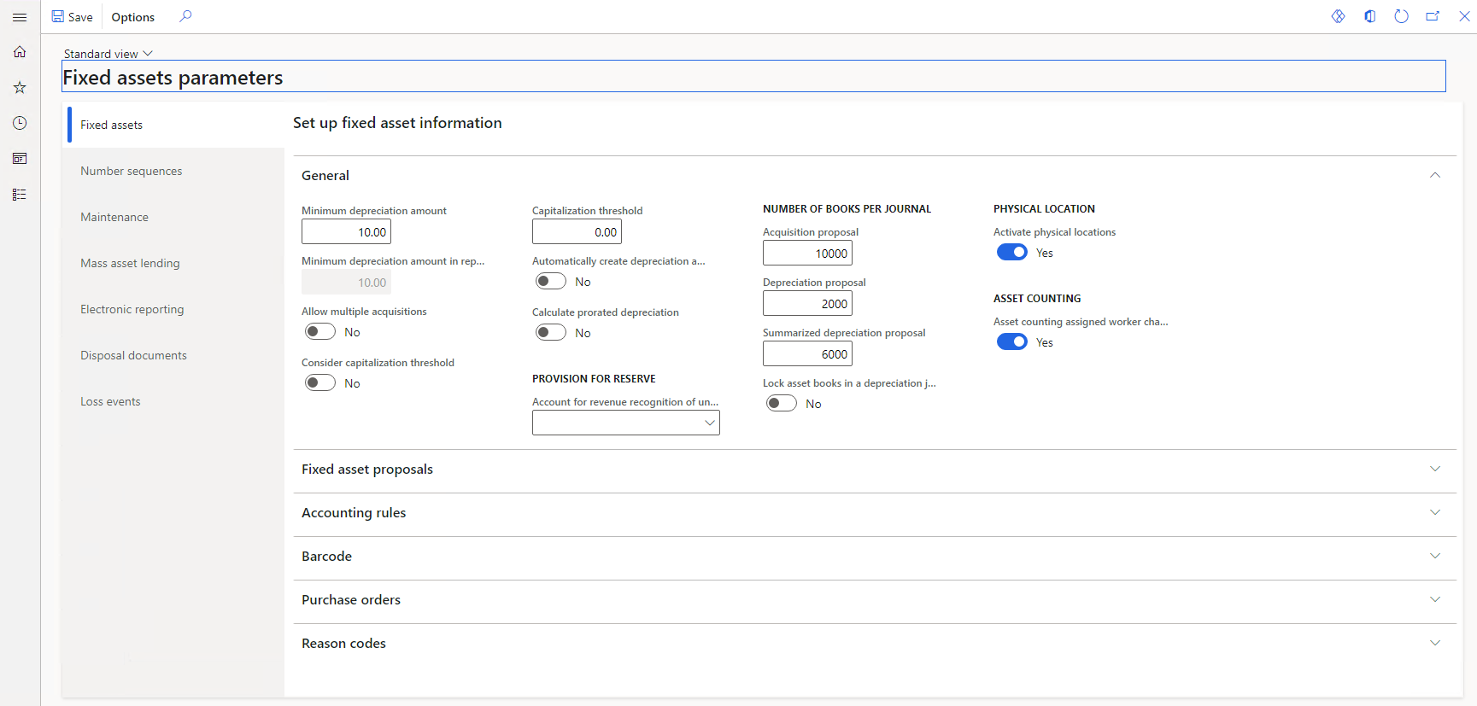
All fields from the table should be in General Fast tab.

Table

Vehicle parts - AXMVehicleParts
In this table we will keep information about available vehicle parts from different vendors and their quantities in storage.

Properties
Properties
Name | AXMVehicleParts
FormRef | AXMVehicleParts
Label | Vehicle parts
Table Group | Group
Modified Date Time | Yes
Modified By | Yes
Created Date Time | Yes
Created By | Yes

Fields
Name | Field type | EDT | Properties
VehiclePartId | String | AXMVehiclePartId | Mandatory: Yes
VehiclePart | Enum | AXMVehiclePart | Mandatory: Yes
VehiclePartQty | Real | AXMPartQty | Mandatory: Yes  Allow Negative: No
VehicleType | Enum | AXMVehicleType | Mandatory: Yes
VehiclePartSerialId | String | InventSerialId | Mandatory: Yes
VehiclePartManufacurer | String | AXMVehicleManufacurer | Mandatory: Yes  Relation:  VendTable.AccountNum  Label: Vehicle part manufacturer
VehiclePartPrice | Real | Price | Label: Vehicle part manufacturer

Indexes
Name | Field list | Properties
VehiclePartIdx, | VehiclePartId | AllowDuplicates: No  AlternateKey: Yes

Additional requirements:
Methods to be implemented: find() and exists() and display method displayManufacurerName() for VehiclePartManufacurer name.
VehiclePartId needs to be number sequence in format: VPID-XXXXX.

Field Groups:
Define them by your own logic of how things should work.
Form
Name | Form Template | Label
AXMVehicleParts | SimpleList | Vehicle parts

DataSource: AXMVehicleParts
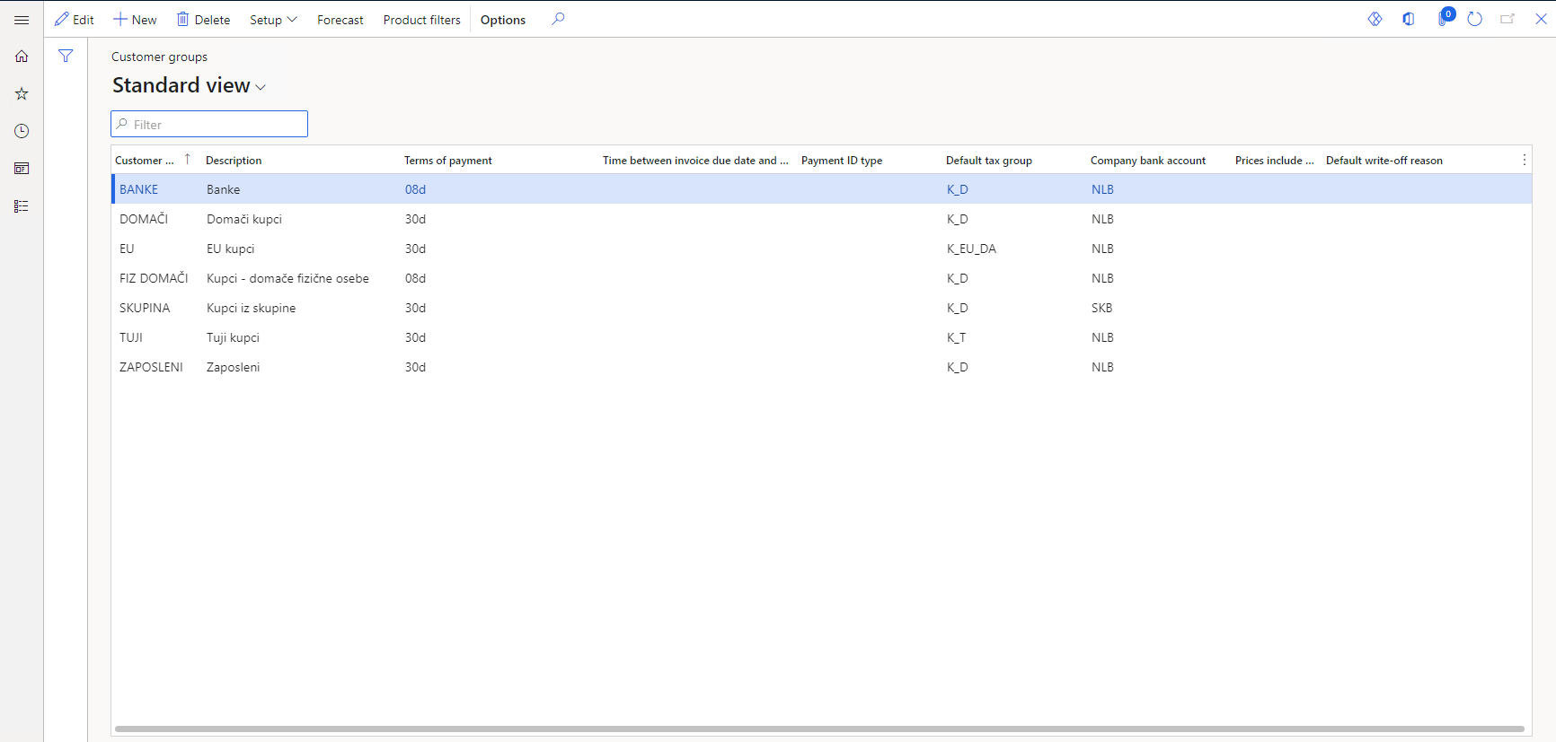
The form should look like: AOT/Forms/CustGroup

Table

Vehicle type parts – AXMVehicleFormula
In this table we will keep the essential specifications for different vehicle types. This will be used for validating if we have all the required parts for one vehicle to be manufactured. For example, for vehicle type Coupe we need one engine, four wheels etc.

Properties
Properties
Name | AXMVehicleFormula
FormRef | AXMVehicleFormula
Label | Vehicle type parts
Table Group | Group
Modified Date Time | Yes
Modified By | Yes
Created Date Time | Yes
Created By | Yes

Fields
Name | Field type | EDT | Properties
VehicleFormulaType | String | AXMVehicleType | Mandatory: Yes
VehicleEngine | Enum | NoYesId | Label: Engine
VehicleChassis | Enum | NoYesId | Label: Chassis
VehicleDoors | Integer | FullQuantity | Allow Negative: No  Label: Doors
VehicleWheels | Integer | FullQuantity | Allow Negative: No  Label: Wheels

Indexes
Name | Field list | Properties
VehicleFormulaTypeIdx | VehicleFormulaType | AllowDuplicates: No  AlternateKey: Yes

Additional requirements:
Methods to be implemented: find() and exists().

Field Groups:
Define them by your own logic of how things should work.

Form
Name | Form Template | Label
AXMVehicleTypeParts | SimpleListDetails | Vehicle type parts

DataSource: AXMVehicleTypeParts
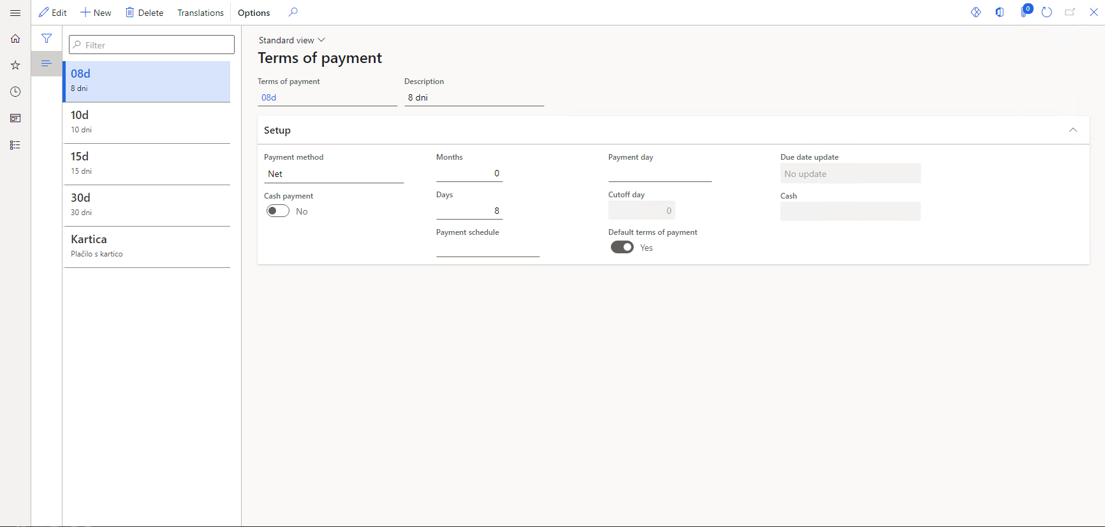
The form should look like: AOT/Forms/PaymTerm

Table

Vehicle table -AXMVehicleTable
In this table we will create the vehicle.

Properties
Properties
Name | AXMVehicleTable
FormRef | AXMVehicleTable
Label | Vehicles
Table Group | WorksheetHeader
Modified Date Time | Yes
Modified By | Yes
Created Date Time | Yes
Created By | Yes

Fields
Name | Field type | EDT | Properties
VehicleId | String | AXMVehicleId | Mandatory: Yes
VehicleColor | String | AXMVehicleColor | Mandatory: Yes
VehicleModel | String |  | Mandatory: Yes
VehicleManufacurer | String | Name | Mandatory: Yes  This will be calculated field with lookup on the form.
VehicleType | Enum | AXMVehicleType | Mandatory: Yes
VehicleAssembleDate | Date | TransDate | Label: Assemble date
Status | Enum | AXMStatus | AllowEdit:No

Indexes
Name | Field list | Properties
VehicleIdx | VehicleId | AllowDuplicates: No  AlternateKey: Yes

Additional requirements:
Methods to be implemented: find() and exists().
Lookup method for VehicleManufacurer and the values will be taken from VendTable.
VehicleId needs to be number sequence in format: VEH-XXXXX.
Field Groups:
Define them by your own logic of how things should work.

Table

Vehicle lines - AXMVehicleLines
In this table we will insert the parts related to the vehicle on the header.

Properties
Properties
Name | AXMVehicleLines
FormRef | AXMVehicleLines
Label | Vehicles
Table Group | WorksheetLines
Modified Date Time | Yes
Modified By | Yes
Created Date Time | Yes
Created By | Yes

Fields
Name | Field type | EDT | Properties | Relation
LineNum |  | LineNum
VehicleId | String | AXMVehicleId | Mandatory: Yes | AXMVehicleTable. AXMVehicleId
VehiclePartId | String | AXMVehiclePart | Mandatory: Yes | AXMVehicleParts. VehiclePartId
VehiclePartName | String | AXMVehiclePart | Mandatory: Yes
VehiclePartManufacurer | String | AXMVehicleManufacurer | Mandatory: Yes
VehiclePartValidated | Enum | NoYesId | AllowEdit: No
VehiclePartQty | Real | AXMPartQty | Mandatory: Yes  Allow Negative: No
VehiclePartPrice | Real | Price

Indexes
Name | Field list | Properties
VehicleLineIdx | VehicleId, VehiclePartId | AllowDuplicates: No  AlternateKey: Yes

Methods to be implemented: find() and exists().
Additional requirements:
When you modify VehiclePartId it will automatically update VehiclePartName and VehiclePartPrice through event handler.
VehiclePartPrice will be calculated field based on quantity of the part in lines and the price of the part.
VehiclePartQty should not exceed vehicle part quantyti from VehicleParts table
Field Groups:
Define them by your own logic of how things should work.

Form

Vehicles list page form
Name | Form Template | Caption
AXMVehiclesListPage | List Page | Vehicles

Datasource: For datasource we will use AXMVehiclesListPage query which is explained later in the document.
Layout and functionalities: The form should have a similar look as the image below. All of the fields from the header that will be shown on the form. The user should be able to add and delete records from this form. On the action pane add two buttons, one will be called “Validate Vehicle” and it will be menu item button that has link to the AXMValidateParts class. The second one will be called “Create Vehicle” and the menu item button will be assigned to the class AXMCreateVehicle – at first this button will be disable till all the lines are not validated.

Create a new New button that should look like SalesCreateOrder form (that is called when you click New on SalesTableListPage) where it will open a new dialog and thought that will create a new record in Vehicle list page form.
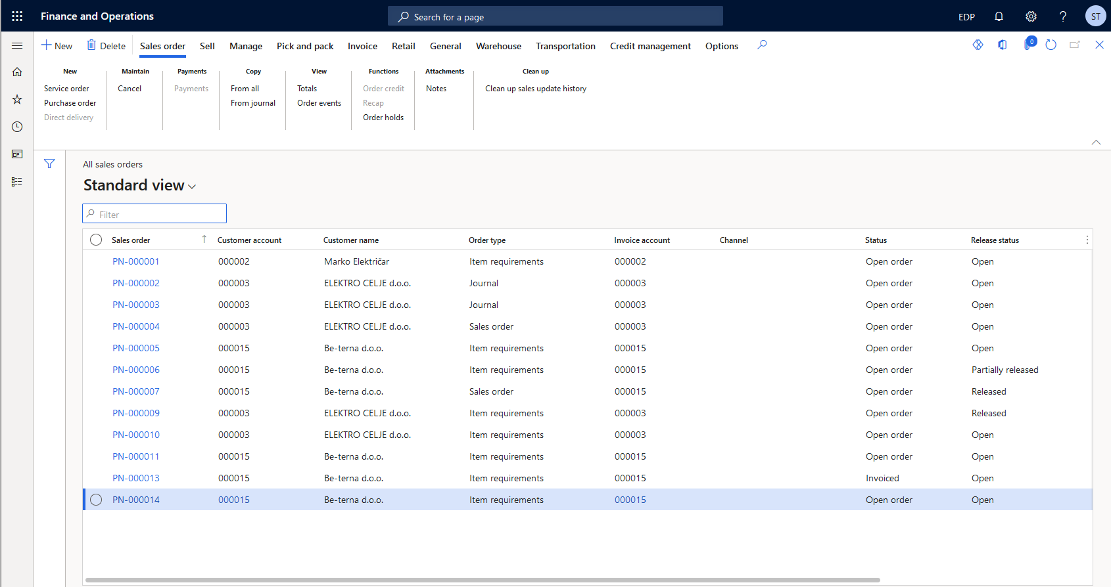
HINT: Use form SalesTableListPage as a reference for creating this form

Vehicles details form
Name | Form Template | Label
AXMVehicles | DetailsTransaction | Vehicles

DataSource: AXMVehicleTable, AXMVehicleLines
The form should look like: AOT/Forms/SalesTable
The details form will have the same action pane as the list page form.
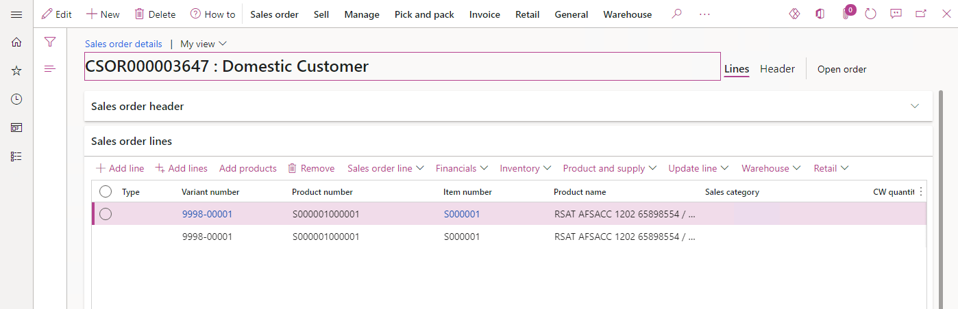
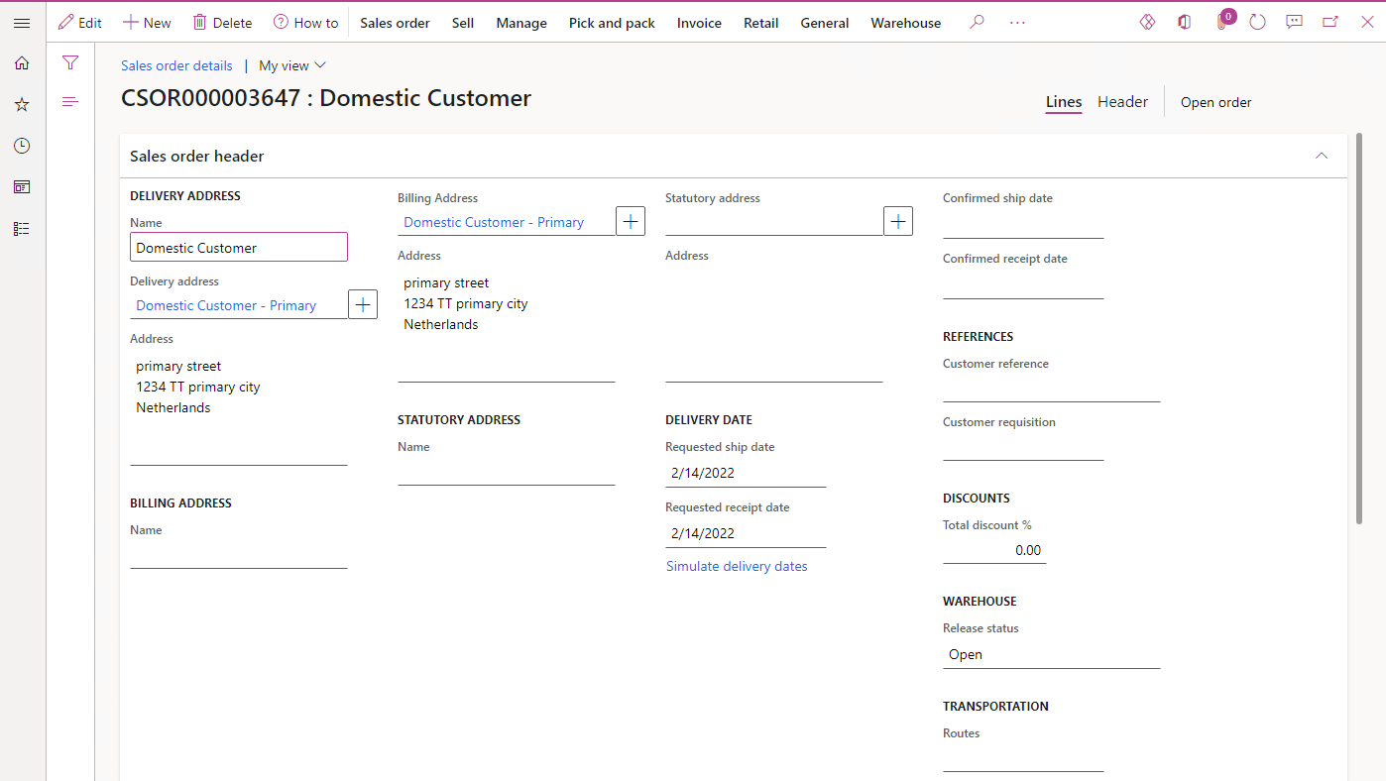

Queries
AXMVehiclesListPage
This query should be used in the list page form for listing vehicle by certain type. If the user clicks the menu item Vehicles by type/ Vehicles by status/Vehicles by date, A value should be added to this query such that vehicles will be filtered according to the selected value. This can be achieved by creating multiple queries and attaching them to menu items or via code, by dynamically adding a value to the original query in the method where query is initialized/executed (depending on which menu item the form was opened).

Classes
AXMValidateParts class
- Create a RunBaseBatch class that will check all of the lines from Vehicle lines for the given Vehicle and if the parts that are inserted satisfies for the vehicle to be created than turn all of the check boxes for the lines to true, show info message “All parts are successfully validated” and enable the “Create Vehicle” button on the Vehicle form. Also set the status on the header to Validated.
- For this class you need to create an action menu item and assign it to the button “Validate Vehicle” on the Vehicle form.

AXMCreateVehicle class
- Create a class that will create an item in the Products form if all the lines are validated. Also, it will check if the assemble date on the vehicle is older than the date specified on the parameters form. If is older than the creating of the vehicle will fail and it will throw an error specifying that the cause of the error. If the vehicle is created, than set the status on the header to Completed.
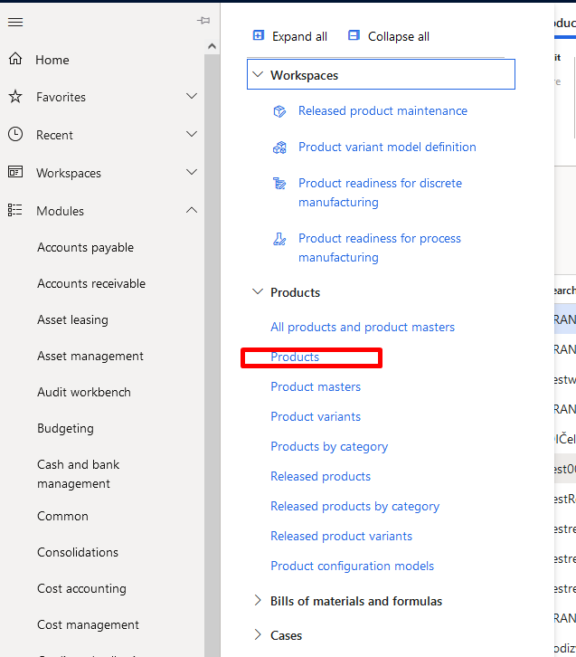

D365 extensions
EcoResProduct table

Fields
Name | Field type | EDT | Properties
VehiclePrice | Real | Price | Label: Vehicle price  AllowNegative: No
VehicleManufacturingDate | Date | TransDate | Label: Vehicle manufacturing date
IsItemVehicle | Enum | NoYesId | Label: Is item a vehicle?  AllowEdit: No

EcoResProductDetails form
On the EcoResProductDetails form extension, we need to create a new tab that will be located under the General tab, and it will have label Vehicle Manufacturing. Inside of the tab, add the newly created fields VehiclePrice and VehicleManufacturingDate. Also on in the General tab, add new group and then add the new IsItemVehicle checkbox.
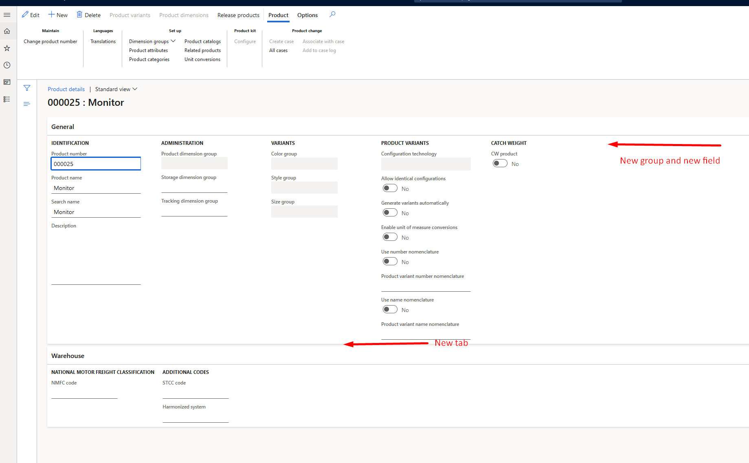

COC extension
Create a COC extension for active method on EcoResProduct datasouce from EcoResProductDetails form that will check if the IsItemVehicle is true or false. Based on that it will make the Vehicle Manufacturing tab visible or not.

Reporting

AXMManufacturedVehiclesReport report
Create new SSRS report that will show manufactured vehicles based on certain period and type. The user should be able to choose from date, to date and type as a parameter to show the specific vehicles, also there should be a parameter field where user can enter threshold price amount. If the user leaves the parameters empty, the report will list all the vehicles. The report should have the following fields VehicleId, VehicleModel, VehicleType, VehiclePartName, VehiclePartQty, VehiclePartPrice.
Lines in the report should be grouped by VehicleId, VehicleModel, VehicleType.
If the VehiclePartPrice is greater than price entered on the parameter, the field should be with red background.
For the data for the report you will need to use the Report Data Provider class.

Menu items
Name | Label | HelpText | ObjectType | Object
AXMVehicleManufacturerParameters | Vehicle manufacturer parameters | General parameters for Vehicle manufacturing. | Form | AXMVehicleManufacturerParameters
AXMVehicleParts | Vehicle parts |  | Form | AXMVehicleParts
AXMVehicleTypeParts | Vehicle type parts | Parts that will be required for given type of vehicle to be build. | Form | AXMVehicleTypeParts
AXMVehiclesListPage | Vehicles | All vehicles | Form | AXMVehiclesListPage
AXMVehiclesByTypeListPage | List vehicles by type |  | Form | AXMVehiclesListPage
AXMVehiclesByDateListPage | List vehicles by date |  | Form | AXMVehiclesListPage
AXMVehiclesByStatusListPage | List vehicles by status |  | Form | AXMVehiclesListPage
AXMValidateParts | Validate Vehicle |  | Class | AXMValidateParts
AXMCreateVehicle | Create Vehicle |  | Class | AXMCreateVehicle
AXMManufacturedVehiclesReport | Manufactured Vehicles |  | SSRSReport | AXMManufacturedVehiclesReport

Menu
Create new menu called: AXMVehicleManufacturer
Label: Vehicle manufacturer
The menu should have 4 areas:
Common: includes all list pages
Vehicle parts: Vehicle parts
Setup: includes Vehicle manufacturer parameters, Vehicle type parts
Reports: Manufactured Vehicles report

Security
Create entry points for all menuitems

